YUVA INTERNSHIP
Junior Data Analyst – Agribusiness
Task 5 : Agribusiness Operation

INTRODUCTION

Cold chain infrastructure plays a pivotal role in enhancing the efficiency and profitability of agricultural value chains, especially for perishable crops like tomatoes, which are highly susceptible to spoilage during post-harvest handling and transportation. In the context of rural Telangana, where smallholder farmers dominate tomato production, the absence of reliable cold storage and refrigerated logistics has led to significant economic losses, market volatility, and reduced farmer incomes.
To address these challenges, the proposed agribusiness initiative aims to develop a decentralized cold chain system comprising:
- Cold storage units in key production clusters
- Refrigerated transport vehicles for regional distribution
- Rural collection centers equipped with grading and packaging facilities
- Farmer training programs to promote best practices in post-harvest management
This integrated approach is expected to:
- Reduce post-harvest losses by preserving crop quality
- Enable farmers to access premium urban and institutional markets
- Create new livelihood opportunities in logistics and agribusiness services
- Strengthen the overall resilience of the tomato supply chain
However, the success of this operation depends on the ability to anticipate and manage a range of risks—including operational bottlenecks, financial constraints, environmental challenges, and stakeholder coordination issues. These risks, if left unaddressed, could undermine the viability and scalability of the initiative.

Risk Identification
The following categories of risk have been identified for the cold chain infrastructure initiative:

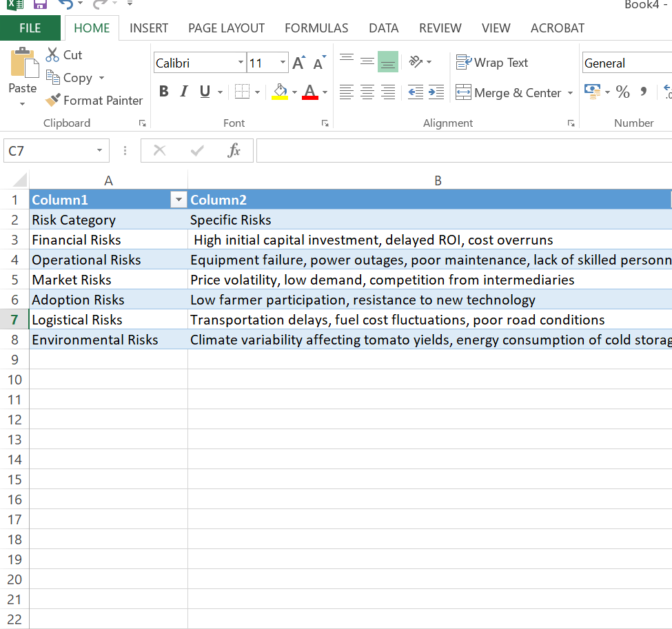

Risk assessment in agribusiness is a structured process aimed at identifying, evaluating, and mitigating uncertainties that could disrupt farming operations or supply chains. It plays a critical role in enhancing decision-making, protecting investments, and ensuring long-term sustainability.

According to the Agriculture Institute, effective risk management is not about eliminating all risks but about minimizing their impact through strategic planning. The process typically involves five key pillars: hazard identification, risk estimation, risk evaluation, control measures, and implementation.

These pillars help agribusinesses systematically address threats such as climate variability, market volatility, and operational failures. A widely adopted tool in this context is the risk matrix, which assesses each risk based on its likelihood and potential impact, allowing stakeholders to prioritize mitigation efforts.

Advanced models also incorporate probability distributions to account for a range of possible outcomes, offering a more nuanced understanding of uncertainty.

As highlighted by CSIRO’s RiskWise framework, vulnerability in agriculture is shaped by exposure and sensitivity, making tailored risk strategies essential. Overall, integrating theoretical models into practical planning empowers agribusinesses to build resilience, improve productivity, and safeguard livelihoods

Risk Estimation
Each risk is evaluated based on its likelihood (Low, Medium, High) and potential impact (Low, Medium, High):

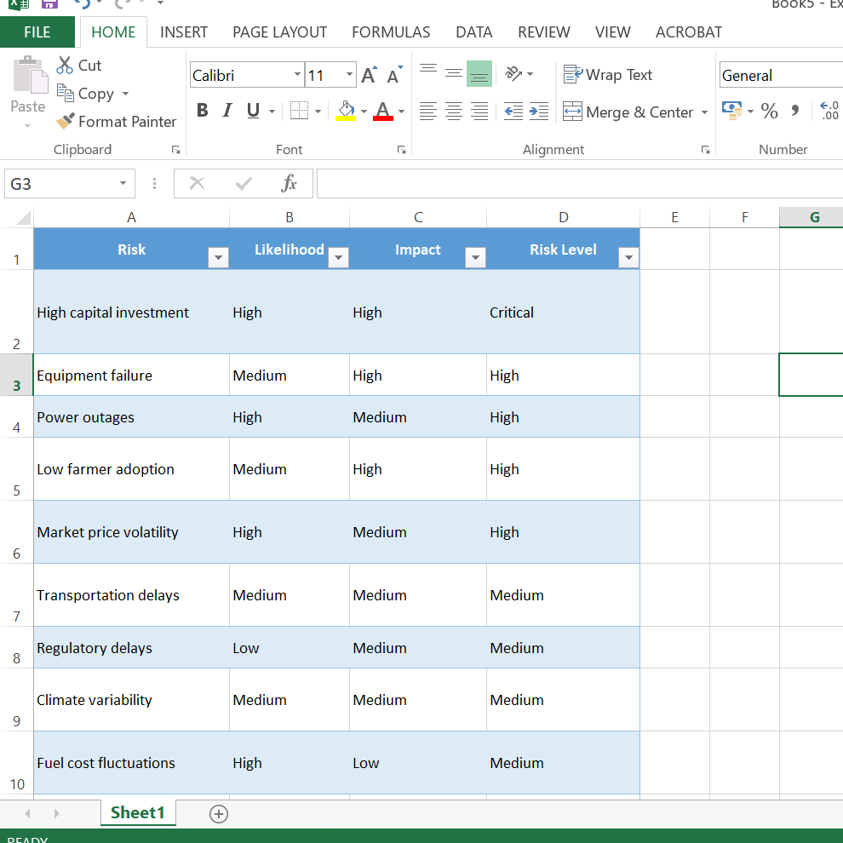

The tomato supply chain in Telangana operates within a highly volatile and infrastructure-deficient environment, making risk assessment a critical tool for strategic planning.

Recent studies highlight that postharvest losses in India’s tomato sector range from 20% to 40%, primarily due to inadequate cold chain infrastructure, poor transport conditions, and lack of temperature-controlled storage facilities. These losses are exacerbated by climate variability, which affects tomato yields and shelf life, especially in regions with extreme temperatures.

Additionally, market dynamics—such as sudden price surges or crashes—create financial uncertainty for farmers, as seen in Telangana where some growers earned over ₹1.8 crore while others faced crop destruction due to low prices. The complexity of the tomato supply chain, involving multiple stakeholders from seed suppliers to retailers, introduces operational and logistical risks that must be addressed through integrated risk management strategies.

Theoretical models like the House of Risk method emphasize mapping risk agents and events across the supply chain to design targeted mitigation actions. By combining empirical data with structured frameworks, agribusinesses can better anticipate disruptions, reduce losses, and enhance resilience across production and distribution stages.

Mitigation Strategies

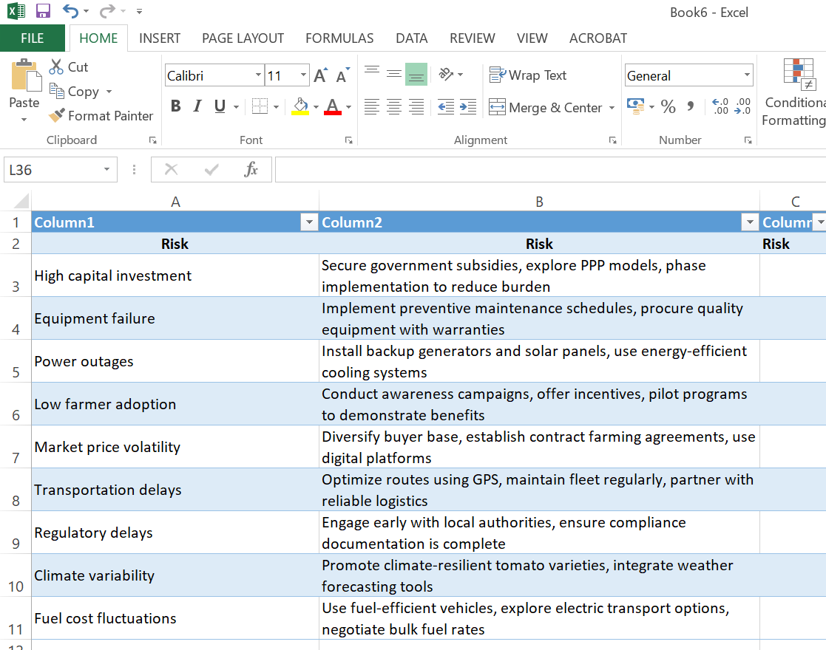

Monitoring and Review

Ongoing Risk Management Practices
Effective risk management is not a one-time exercise—it’s a continuous process that evolves with the realities on the ground. For a cold chain operation serving smallholder tomato farmers in Telangana, staying responsive to operational shifts, market dynamics, and stakeholder needs is essential. The following practices are recommended to ensure that risks are not only identified but actively managed throughout the lifecycle of the project.

Quarterly Risk Audits
Conducting quarterly audits allows the team to pause, reflect, and recalibrate. These reviews should focus on both operational and financial dimensions:
- Are cold storage units functioning optimally?
- Are transport routes cost-effective and timely?
- Are financial projections holding up against actual performance?
By systematically reviewing these areas every three months, the operation can catch inefficiencies early, adjust strategies, and maintain accountability across teams.

Performance Dashboards
Dashboards serve as a real-time pulse check on the system. They should track key performance indicators such as:
- Spoilage rates, to assess the effectiveness of cold storage and transport
- Farmer participation, to gauge engagement and trust in the system
- Transport efficiency, to monitor delivery timelines and route optimization
These metrics should be updated regularly and made accessible to both field teams and decision-makers. When interpreted thoughtfully, they provide not just data—but insight into where improvements are needed and where the system is thriving.

Stakeholder Feedback
The people closest to the operation—farmers, buyers, and logistics partners—are often the first to notice emerging risks. Their input is invaluable. Establishing regular feedback channels, whether through structured surveys, informal check-ins, or monthly review meetings, helps surface issues that might not be visible in the data alone.
For example, farmers might report delays in pickup, buyers might flag inconsistencies in product quality, and transport partners might highlight challenges with road conditions or fuel costs. Listening to these voices ensures the system remains grounded in reality and responsive to those it serves.

Contingency Planning
Even with the best systems in place, disruptions are inevitable. That’s why contingency planning is critical. Emergency protocols should be developed and regularly updated to address:
- Equipment failures, with backup generators, mobile cold units, and rapid repair services
- Market disruptions, through diversified buyer networks and flexible pricing models
- Regulatory changes, by maintaining up-to-date compliance procedures and training staff accordingly
These plans should be clear, actionable, and communicated across all levels of the operation. The goal is not to eliminate risk entirely, but to ensure that when challenges arise, the response is swift, coordinated, and minimizes impact.

CONCLUSION

The cold chain infrastructure initiative for tomato farmers in Telangana presents a high-impact opportunity to modernize the supply chain and improve farmer livelihoods. However, its success depends on proactive risk management across financial, operational, market, and environmental dimensions. This report identifies critical risks and outlines feasible mitigation strategies that can be integrated into the project’s planning and execution phases.
By adopting a structured risk management framework, stakeholders can minimize disruptions, enhance resilience, and ensure the long-term sustainability of the agribusiness operation. The initiative remains viable and promising, provided that risks are continuously monitored and addressed with agility and collaboration.

THANK YOU

